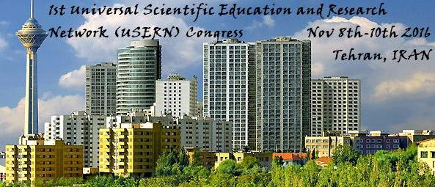

1st Universal Scientific Education and Research Network (USERN) Congress

& the Festival for awarding the USERN Prize

November 8th, Tuesday

7:30 – 8:30: Registration

Main Hall
8:30 – 9:15: Opening Session
9:15 – 10:00: USERN Nobel Talk (UNT)
9:15 – 9:20: Cell replacement therapy: Introduction/Performance
9:20 – 10:00: Nuclear reprogramming as a route to cell replacement therapy. John Gurdon (UK) [Nobel Laureate 2012]
10:00 – 10:30: Coffee break
10:30 – 13:00: USERN Keynote Lectures (UKL)
Moderators: Ali Akbar Moosavi-Movahedi, Reza Tavakkoli-Moghaddam, Sadollah Nasiri Gheydari, Roja Rahimi
10:30 – 10:40: Origins of the genes: Introduction/Performance
10:40 – 11:10: What the genes tell us about our origins, evolutionary history and our current health. Francesco Cucca (Italy)
11:10 – 11:15: Climate change: Introduction/Performance
11:15 – 11:45: Climate change and global warming. Hai Cheng (China)
11:45 – 11:55: The earth: Introduction/Performance
11:55 – 12:25: Earth: Our ever changing planet? Timothy W. Lyons (USA)
12:25 – 12:30: The universe: Introduction/Performance
12:30 – 13:00: The universe: Conception and evolution. Bahram Mobasher (USA)
13:00 – 14:00: Lunch break
14:00 – 16:00: Plenary Panel
14:00 – 14:05: Uncertainty in life: Introduction/Performance
14:00 – 14:15: Uncertainty in life. Tamsin Edwards (UK)
14:15 – 16:00: Layers of depth: Science from galaxy to genome
Moderators: John Gurdon (UK), Francesco Cucca (Italy), Timothy W. Lyons (USA), Hai Cheng (China), Bahram Mobasher (USA)
Facilitator: Tamsin Edwards (UK)

Conference Room 2
10:30 – 12:30: Focused Group Discussion (FGD) 2 [Limited number of seats. Registration is on a first come, first served basis]
How would networking change our lives in the future? The dawn of a new era. Guanrong Chen (Hong Kong, China)
14:00 – 16:00: Focused Group Discussion (FGD) 1 [Limited number of seats. Registration is on a first come, first served basis]
Analytical glance at leadership and problem-solving capabilities. Michael D. Mumford (USA)
Conference Room 3
10:30 – 12:30: Focused Group Discussion (FGD) [Limited number of seats. Registration is on a first come, first served basis]
Social Conception and perception of laughing: Our perception of laughter tells us what laughter is talking about. Willibald Ruch (Switzerland)

* 18:00 – 22:00: Social Program [Limited number of seats. Registration is on a first come, first served basis]
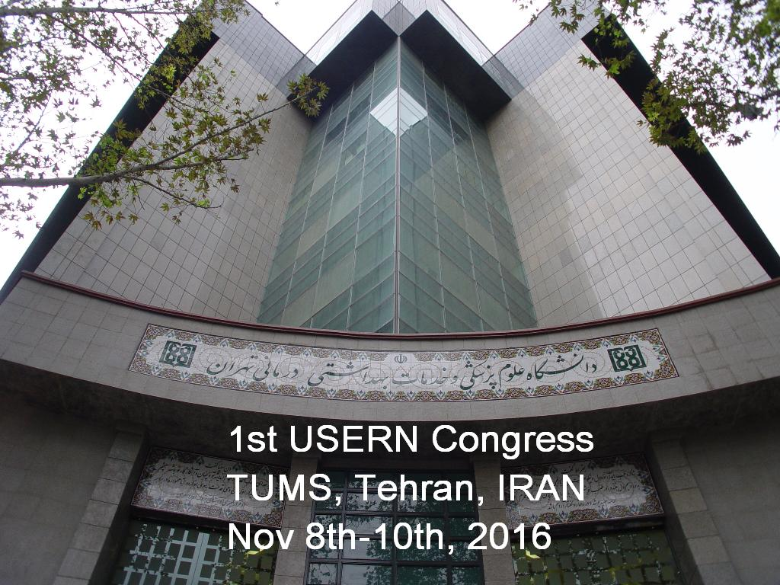
November 9th, Wednesday

7:30 – 8:30: Breakfast Meetings with top scientists (parallel) [Limited number of seats. Registration is on a first come, first served basis]

Main Hall
8:30 – 9:00: USERN Able Virtual Talk (UAVT)
8:30 – 8:35: Philosophy of science: Introduction/Performance
8:35 – 9:00: Remarks on mathematics. Louis Nirenberg (Canada) [Abel Laureate 2015]
9:00 – 10:30: USERN Keynote Lectures (UKL)
Moderators: Parviz Norouzi, Ahmad Reza Dehpour, Mehrdad Hamidi, Farnoush Faridbod
9:00 – 9:05: Renewable energy: Introduction/Performance
9:05 – 9:30: Renewable energy: past, present, future. Jamshid Aghaei (Iran)
9:30 – 9:35: Human brain: Introduction/Performance
9:35 – 10:00: An interdisciplinary insight into the human brain: Advances in the third millennium. Alexander Leemans (the Netherlands)
10:00 – 10:05: Neuroscience today: Introduction/Performance
10:05 – 10:30: The golden age of neuroscience, neurology and neurotherapeutics has arrived! (Olaf Stuve, USA)
10:30 – 11:00: Coffee break
11:00 – 13:00: USERN Keynote Lectures (UKL)
Moderators: Reza Majdzadeh, Abolfazl Akbarzadeh, Saied Pakniat, Farzaneh Shemirani
11:00 – 11:05: Measurement of science: Introduction/Performance
11:05 – 11:30: Measures of science: merits and dangers of rankings in higher education. Michael Schreiber (Germany)
11:30 – 11:35: Big data: Introduction/Performance
11:35 – 12:00: Big data: The hardships of interpretation. Balakrishnan Narayanaswamy (Canada)
12:00 – 12:05: Teamwork: Introduction/Performance
12:05 – 12:30: Future of nanomedicine: impact of teamwork. Morteza Mahmoudi (Iran, USA)
12:30 – 12:35: Networking: Introduction/Performance
12:35 – 13:00: Network science and engineering: The dawn of a new era. Guanrong Chen (Hong Kong, China)
13:00 – 14:00: Lunch break
14:00 – 16:00: Plenary Panel
14:00 – 14:05: Past, present, and future: Introduction/Performance
14:05 – 14:15: Progress in multidisciplinary approaches to the sciences from the past to the future. Laily Mahoozi (Iran)
14:15 – 16:00: Timely trends in science
Moderators: Michael Schreiber (Germany), Balakrishnan Narayanaswamy (Canada), Guanrong Chen (Hong Kong, China), Olaf Stuve (USA), Morteza Mahmoudi (Iran, USA), Jamshid Aghaei (Iran), Alexander Leemans (the Netherlands)
Facilitators: Laily Mahoozi (Iran) and Afsaneh Shirani (USA)

Conference Room 2
8:30 – 10:30: Focused Group Discussion (FGD) 4 [Limited number of seats. Registration is on a first come, first served basis]
Resistance to nuclear reprogramming by eggs. John Gurdon (UK)

11:00 – 13:00: Focused Group Discussion (FGD) 5 [Limited number of seats. Registration is on a first come, first served basis]
Genetic regulation of the immune system in health and disease. Francesco Cucca (Italy)
14:00 – 16:00: Focused Group Discussion (FGD) 6 [Limited number of seats. Registration is on a first come, first served basis]
The evolution of food: what will we eat in the next century? José Alfredo Martínéz (Spain)

Conference Room 3
11:00 – 13:00: Focused Group Discussion (FGD) 7 [Limited number of seats. Registration is on a first come, first served basis]
Uncertainty in earth system modeling. Tamsin Edwards (UK)
14:00 – 16:00: Focused Group Discussion (FGD) 8 [Limited number of seats. Registration is on a first come, first served basis]
Climate change and human civilization/Culture history. Hai Cheng (China)

* 17:00 – 21:00: USERN Advisory Board Meeting [Open just for invited USERN advisory board members]

November 10th, Thursday

7:30 – 8:30: Breakfast Meetings with top scientists (parallel) [Limited number of seats. Registration is on a first come, first served basis]

Main Hall
8:30 – 10:30: USERN Keynote Lectures (UKL)
Moderators: Mohammad Abdollahi, Davood Domiri Ganji, Shekoufeh Nikfar, Leila Azadbakht
8:30 – 8:35: Human physics: Introduction/Performance
8:35 – 9:00: Human physics: Neutrigenetics and epigenetics of obesity. José Alfredo Martínéz (Spain)
9:00 – 9:05: Creativity: Introduction/Performance
9:05 – 9:30: Creativity: are we killing or improving it? Michael D. Mumford (USA)
9:30 – 9:35: Happiness: Introduction/Performance
9:35 – 10:00: Stumbling on happiness or mumbling a value? Willibald Ruch (Switzerland)
10:00 – 10:05: Format of thoughts: Introduction/Performance
10:05 – 10:30: What are the building blocks of thoughts. Floris De Lange (the Netherlands)
10:30 – 10:35: Nostalgia: Introduction/Performance
10:35 – 11:00: Nostalgia uplifts the human spirit. Constantine Sedikides (UK)
11:00 – 11:30: Coffee break
11:30 – 13:30: Plenary panel
11:30 – 11:35: Man and machine interaction: Introduction/Performance
11:35 – 11:45: Man and machine interaction- technology for sustaining life on earth. Lucas Joppa (USA)
11:45 – 11:50: Human dimensions: Introduction/Performance
11:50 – 12:00: Human entity and scientific paradigm. Shervin Vakili (Iran)
12:00 – 13:30: Human dimensions: Science of creature
Moderators: José Alfredo Martínéz (Spain), Michael D. Mumford (USA), Willibald Ruch (Switzerland), Constantine Sedikides (UK), Floris P De Lange (the Netherlands)
Facilitator: Shervin Vakili (Iran)

Conference Room 2
8:30 – 10:30: Focused Group Discussion (FGD) 10 [Limited number of seats. Registration is on a first come, first served basis]
In search of the origins: From universe to life. Bahram Mobasher (USA)
11:30 – 13:30: USERN Junior Talks
Moderators: Mofid Gorji, Omid Bozorg Haddad, Fariborz July, Hassan Bagheri

Conference Room 3
8:30 – 10:30: Focused Group Discussion (FGD) 11 [Limited number of seats. Registration is on a first come, first served basis]
Simulations in culture and science and their relation to reality. Michael Schreiber (Germany)
11:30 – 13:30: Focused Group Discussion (FGD) 9 [Limited number of seats. Registration is on a first come, first served basis]
How earth's distant past guides the search for life in the universe. Timothy W. Lyons (USA)

* 18:00 – 21:00: Closing ceremony and awarding festival
* 21:00 – 23:00: Gala Dinner with top scientists [Limited number of seats. Registration is on a first come, first served basis]

